John Ritter, Roy Rogers, Rex Allen, Jimmy Wakeley Photo

Ship From:

Alan Blank

1835 caddington Dr. #38
Rancho Palos Verdes, CA 90275 / USA

Ship To:

Roy R. Dillow
P.O. Box 535
Tazewell, VA, 24651

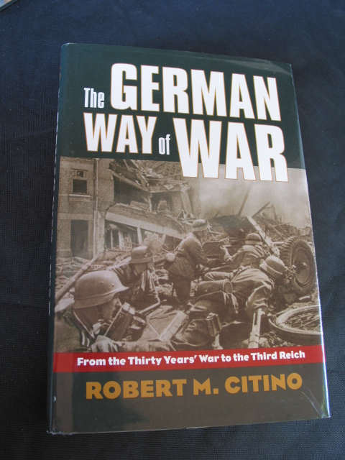
The German Way of WAR

Ship From:

Alan Blank

1835 caddington Dr. #38
Rancho Palos Verdes, CA 90275 / US

Ship To:

Wolfgang Schoenfeld
Box 224

3610 W. 2nd Ave.
MANSFIELD, GA 30055

MOJ

Ship From:

Alan Blank

1835 caddington Dr. #38
Rancho Palos Verdes, CA 90275 / US

Ship To:

David Spitzer
6424 se 77th ave
Portland, OR 97206

1890-1940s Bicycle Brochures Book

Ship From:

Alan Blank

1835 caddington Dr. #38
Rancho Palos Verdes, CA 90275 / US

Ship To:

Daniel S. Venturi
12075 US Highway 59
Oswego, KS 67356

1940s Bell Systems "Lucy Phone"

Ship From:

Alan Blank

1835 caddington Dr. #38
Rancho Palos Verdes, CA 90275 / US

Ship To:

Dave Kingston
1100 Park Central Blvd S
Broward County Transportation Dept. Ste 3500
Pompano Beach, FL 33064

Ferrari Owners Club 1982-1983, Membership Directory

Ship From:

Alan Blank

1835 caddington Dr. #38
Rancho Palos Verdes, CA 90275 / US

Ship To:

Berthold Lammeck
Stahlbaustrasse 8
c/o VESTATEC
D-44577 Castrop-Rauxel
Germany

6 1936 Large Photos Of the Gainesville Georgia Tornado

Ship From:

Alan Blank

1835 caddington Dr. #38
Rancho Palos Verdes, CA 90275 / US

Ship To:

Donna Nash
PO Box 908484
Gainesville, GA 30501

1920 Alabama, Virginia, Indiana Farm Family Photo Album

Ship From:

Alan Blank

1835 caddington Dr. #38
Rancho Palos Verdes, CA 90275 / US

Ship To:

Lorna Wallace
1 Daniel Burnham Court
#1504
San Francisco, CA 94109

1960s RED GTE Rotary Dial Cord Phone

Ship From:

Alan Blank

1835 caddington Dr. #38
Rancho Palos Verdes, CA 90275 / US

Ship To:

Richard Butler
102 W.Spring St.
Anna, IL 62906

8 books comedy

Ship From:

Alan Blank

1835 caddington Dr. #38
Rancho Palos Verdes, CA 90275 / US

Ship To:

SWEET PEA COTTAGE~BRAIDED RUGS
19837 Hidden Hills Rd.
Cottonwood, CA 96022

Valve covers / 281- 787-7011

Ship From:

Alan Blank

1835 caddington Dr. #38
Rancho Palos Verdes, CA 90275 / US

Ship To:

Darrell Heath
12703 Hunters Canyon
Cypress, TX 77429

8 books comedy

Ship From:

Alan Blank

1835 caddington Dr. #38
Rancho Palos Verdes, CA 90275 / US

Ship To:

SWEET PEA COTTAGE~BRAIDED RUGS
19837 Hidden Hills Rd.
Cottonwood, CA 96022

WWII 1943 Conventional Signs, Military Symbols

Ship From:

Alan Blank

1835 caddington Dr. #38
Rancho Palos Verdes, CA 90275 / US

Ship To:

John Runion, Sr.
11614 PRIMWOOD DR
HOUSTON, TX 77070-2536

1934 Empress of Britain / Canadian Pacific Letter, Rare

Ship From:

Alan Blank

1835 caddington Dr. #38
Rancho Palos Verdes, CA 90275 / US

Ship To:

Fella F. Livermore
4805 Sorrento CT Unit 4
Cape Coral, FL 33904

1934 Empress of Britain / Canadian Pacific Letter, Rare

Ship From:

Alan Blank

1835 caddington Dr. #38
Rancho Palos Verdes, CA 90275 / US

Ship To:

Fella F. Livermore
4805 Sorrento CT Unit 4
Cape Coral, FL 33904

1934 Empress of Britain / Canadian Pacific Letter, Rare

Ship From:

Alan Blank

1835 caddington Dr. #38
Rancho Palos Verdes, CA 90275 / US

Ship To:

Fella F. Livermore
4805 Sorrento CT Unit 4
Cape Coral, FL 33904

1934 Empress of Britain / Canadian Pacific Letter, Rare

Ship From:

Alan Blank

1835 caddington Dr. #38
Rancho Palos Verdes, CA 90275 / US

Ship To:

Fella F. Livermore
4805 Sorrento CT Unit 4
Cape Coral, FL 33904

1934 Empress of Britain / Canadian Pacific Letter, Rare

Ship From:

Alan Blank

1835 caddington Dr. #38
Rancho Palos Verdes, CA 90275 / US

Ship To:

Fella F. Livermore
4805 Sorrento CT Unit 4
Cape Coral, FL 33904

1934 Empress of Britain / Canadian Pacific Letter, Rare

Ship From:

Alan Blank

1835 caddington Dr. #38
Rancho Palos Verdes, CA 90275 / US

Ship To:

Fella F. Livermore
4805 Sorrento CT Unit 4
Cape Coral, FL 33904

1934 Empress of Britain / Canadian Pacific Letter, Rare

Ship From:

Alan Blank

1835 caddington Dr. #38
Rancho Palos Verdes, CA 90275 / US

Ship To:

Fella F. Livermore
4805 Sorrento CT Unit 4
Cape Coral, FL 33904

1934 Empress of Britain / Canadian Pacific Letter, Rare

Ship From:

Alan Blank

1835 caddington Dr. #38
Rancho Palos Verdes, CA 90275 / US

Ship To:

Fella F. Livermore
4805 Sorrento CT Unit 4
Cape Coral, FL 33904

1934 Empress of Britain / Canadian Pacific Letter, Rare

Ship From:

Alan Blank

1835 caddington Dr. #38
Rancho Palos Verdes, CA 90275 / US

Ship To:

Fella F. Livermore
4805 Sorrento CT Unit 4
Cape Coral, FL 33904

1934 Empress of Britain / Canadian Pacific Letter, Rare

Ship From:

Alan Blank

1835 caddington Dr. #38
Rancho Palos Verdes, CA 90275 / US

Ship To:

Fella F. Livermore
4805 Sorrento CT Unit 4
Cape Coral, FL 33904

1934 Empress of Britain / Canadian Pacific Letter, Rare

Ship From:

Alan Blank

1835 caddington Dr. #38
Rancho Palos Verdes, CA 90275 / US

Ship To:

Fella F. Livermore
4805 Sorrento CT Unit 4
Cape Coral, FL 33904

