http://www.kay.com/webapp/wcs/stores/servlet/product1%7C10101%7C10001%7C-1%7C990336606%7C15052%7C15052.15060

The Leo Diamond®
- » Rings
- » Earrings
- » Necklaces and Pendants
- » 3-Stone Diamond
What's your birthstone?
Quick guide to each
month and its birthstone.
View

The Kay card
Apply now
60-day money-
back guarantee*
Learn more
Important Consumer Information
Read more


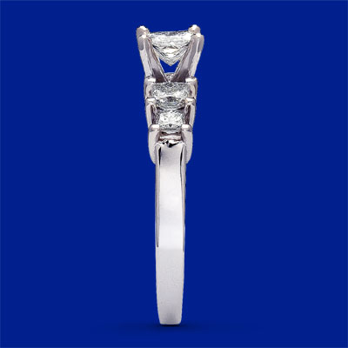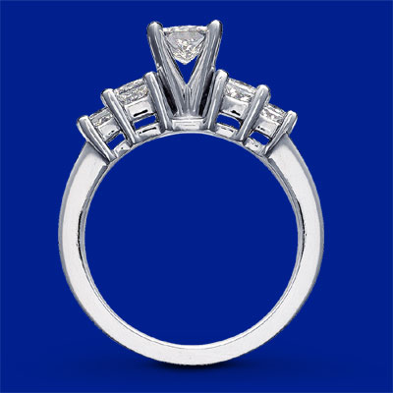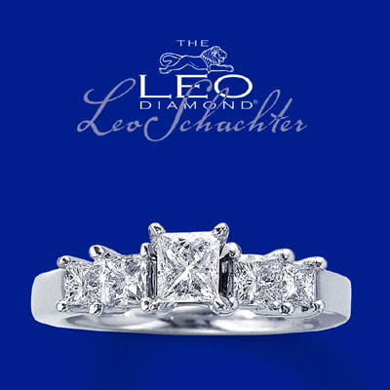

14K White Gold 1 1/6 Carat t.w. Leo Diamond Ring
This contemporary 1 1/6 carat t.w. ring has a princess-cut Leo diamond as the brilliant centerpiece. A pair of princess-cut diamonds on either side completes the look. Set in platinum on a band of 14K white gold. Independently Certified and laser-inscribed with a unique Gemscribe® serial number. The inside of the band features a round diamond within the Leo signature. Available at select Kay Jewelers locations -- call 1-800-527-8029 for the store nearest you.

Price: $4,899.99
The standard size for this ring is 6.75. If you choose a different size, a service charge will be applied.
Ring sizing services will take up to three business days before the order is shipped.
Ring size help

Add to wish list | Print Page

Product Details:
Stock number: | 990336606
Metals: | 14 KARAT WHITE GOLD
Diamond Total Weight: | 1 1/6 CT.
Primary Diamond Cut: | LEO PRINCESS-CUT
Primary Diamond Color: | HI
Primary Diamond Clarity: | SI1-SI2
Primary Diamond Setting: | PRONG SETTING
Primary Diamond Weight: | 1/2 CT.
Primary Diamond Certification: | YES AND GEMEX
Primary Diamond Gemscribe: | YES
Diamond Sidestone Cuts: | 4 LEO PRINCESS-CUTS
Diamond Sidestone Minimum Color: | HI
Diamond Sidestone Minimum Clarity: | SI2-I1
Diamond Sidestone Settings: | PRONG SETTING
Dimension Height: | 4.00MM
Metal Prong Metal: | PLATINUM
Maximum Size: | 8.5
Diamond Sidestone Certification: | YES AND GEMEX
Stock Size: | 6.75
Minimum Size: | 5
Step Size: | 0.5
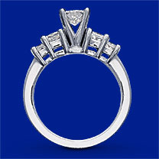

Price: $4,899.99
Ring size help

Add to wish list | Print Page

