1.45 Ct AAA Flawless Investment Grade Tanzanite

Buy Sell My eBay Community Help

##1##
##2##

Back to My eBay Listed in category: Jewelry & Watches > Loose Diamonds & Gemstones > Gemstones > Tanzanite > Other Shapes

$1740 CERTIFIED NATURAL TANZANITE 1.45ct AAA+
FLAWLESS INVESTMENT GRADE. AMAZING COLOR Item number: 110177557994

This item has been paid through PayPal. Payment was sent to: dogdooz@bellsouth.net on Oct-13-07.

Other actions for this item:
You can manage all your items in My eBay and do the following:
View Order Details
View PayPal payment for this item.
Contact Seller about this item.
Additional Options:
To view other items from this seller, view seller's other items.
If this listing is similar to an item you want to sell, list an item like this.
You may add this seller to your Favorite Sellers in My eBay.
To report that this item hasn't been received, you can report the item as not received.

This item has been added to My eBay for Guests.
As a guest, you can:
Track up to 10 items on this computer in My eBay
Receive an email reminder for this item a few hours before it ends

1 of 4

View larger picture

Winning bid: US $386.56

No payments for 90 days Apply

--------------------------------------------------------------------------------

Ended: Oct-11-07 20:10:23 PDT
Shipping costs: US $9.00
US Postal Service Priority Mail®
Service to United States
(more services)
Ships to: Worldwide
Item location: Hartsdale, NY, United States
History: 18 bids
Winning bidder: lovesmusic2( 439)

--------------------------------------------------------------------------------

You can also: Email to a friend

Listing and payment details: HideShow
Starting time: Oct-04-07 20:10:23 PDT
Starting bid: US $9.99
Payment methods: PayPal
See details

Meet the seller
Seller: finickyfacets( 222)
Feedback: 99.6% Positive
Member: since Jan-07-07 in United States

See detailed feedback
Ask seller a question
Add to Favorite Sellers
View seller's other items

Contact the seller instantly

Buy safely
1. Check the seller's reputation
Score: 222 | 99.6% Positive
See detailed feedback
2. Check how you're protected

Up to $2,000 in buyer protection. See eligibility

Returns: Seller accepts returns.
3 Days Money Back

Description

PRICES ARE EXPECTED TO GO UP ON TANZANITE IN DECEMBER.

Tanzanite is a rare gemstone variety of the mineral zoisite. Discovered in 1967 at the foothills of Mount Kilimanjaro at the site that remains its only known source, tanzanite has been described as 'a geological phenomenon'. With its exquisite violet-blue hues and incomparable rarity, tanzanite has become recognised as a mainstream gemstone, competing with the likes of ruby, emerald and sapphire. As testimony to this, tanzanite was rated fourth most popular coloured gemstone in the US in 2002 and in 2003, the American Gem Trade Association named tanzanite a December birthstone, adding to a list previously unchanged since 1912.

Tanzanite's only known source in the world is a 5km strip of land near Mount Kilimanjaro, northern Tanzania. This single, limited source renders tanzanite at least a thousand times rarer than diamonds.

In the meantime, almost any price you care to name is being asked - and paid! - for tanzanites of good quality and large size. What makes this stone so popular? Is it simply that fantastic colour? No, it is also the exclusivity of its origin. The stone is particularly highly prized because it is found in only one place in the whole world. The idea of possessing something that not everyone has has always been one of the main criteria in the way we esteem special gems.

WE ARE STRIVING TO BE THE NUMBER ONE SOURCE ON TOP GEM QUALITY TANZANITE.

Hand picked for Color,Cut, Clarity and Saturation.

TOP GEM GRADE AAA+, INTENSE SATURATION. DARK TONE

Perfect D-Block Blue Color w/just the right amount of purple highlights.

THIS IS A STUNNING EXAMPLE OF FINE TANZANITE

COMES WITH CERTIFICATE

Click to play video to see this fabulous Tanzanite.

TANZANITE DETAILS CLARITY LOUPE CLEAN(FLAWLESS)
CARAT WEIGHT 1.45ct
SIZE 7x7x3.9
SHAPE ANTIQUE CUSHION
CUT EXCELLENT
COLOR D-BLOCK DEEP BLUE W/ VIOLET UNDERTONES

ORIGIN TANZANIA

NORMAL PRICE $1740.00 AND WILL BE GOING OVER $2000 A CARAT SOON.

THIS IS THE ACTUAL TANZANITE YOU WILL RECEIVE.

Photograph was taken under an Ott natural light. This is the closest light to that of sunlight. Different lighting can either make your Tanzanite washed or eye popping. Have you ever purchased a nice piece of Tanzanite or any other gemstone in a fine jewelry store and gotten it home only to find it no longer looked alive as it did in the store? Lighting is everything. When you receive your Tanzanite, View it under different light sources ,especially the sunlight to fully appreciate the full spectrum of colors and luster it has to offer.

Please keep in mind that all stones will appear even darker once set in a setting.

BID/BUY WITH CONFIDENCE

You will not be disappointed.

CHECK OUR FEEDBACK

If you have any Questions, ask and I will get back to you as soon as possible.

PLEASE READ:

Tanzanite as well as other colored gemstones are not to be cleaned in ultrasonic cleaners, the stone can become damaged. Use a mild soap and rinse well with warm water or a liquid jewelry cleaner.

If you are mailing payment with Postal money order, please communicate with us as to when payment can be expected. If there is no communication or payment within 7 days of the close of the auction, it will be sold. We don't mind waiting as long as you let us know.

FEEDBACK

Before leaving anything but positive feedback, please give us the opportunity to work with you.

We love to give and receive positive feedback. We will leave the same once it is left for us.

Thank You
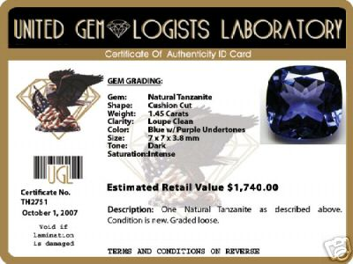 \

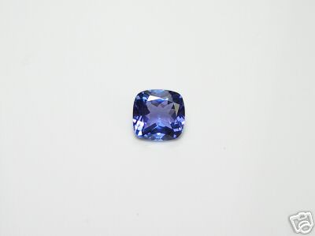

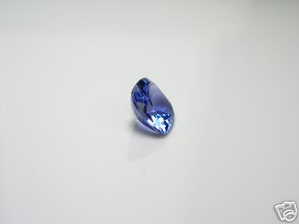

CLARITY | LOUPE CLEAN(FLAWLESS)
CARAT WEIGHT | 1.45ct
SIZE | 7x7x3.9
SHAPE | ANTIQUE CUSHION
CUT | EXCELLENT
COLOR | D-BLOCK DEEP BLUE W/ VIOLET UNDERTONES
ORIGIN | TANZANIA

