    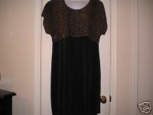
    View larger picture
    Winning bid: | US $1.99
    Ended: | Nov-19-06 12:04:00 PST
    Shipping costs: | US $4.25  US Postal Service Priority Mail®  Service to United States
    Ships to: | United States
    Item location: | Yukon, Oklahoma, United States
    History: | 1 bid
    Winning bidder: | lovesmusic2( 395)
    You can also: | Email to a friend | Sell one like this
  Listing and payment details: Show
    Starting time: | Nov-12-06 12:04:00 PST
    Starting bid: | US $1.99
    Payment methods:
      PayPal (preferred),
      Money order/Cashiers check
      See details
  Meet the seller
  Seller: | cubswin016( 2676)
  Feedback: | 99.7% Positive
  Member: | since Jul-02-04 in United States
  Read feedback comments
  Ask seller a question
  Add to Favorite Sellers
  View seller's other items: Store | List
  Visit seller's Store:
  Marianne's House
  Contact the seller instantly
  Buy safely
  1. | Check the seller's reputation
  Score: 2676 | 99.7% Positive
  Read feedback comments
  2. | Check how you're protected
    This item is covered up to $1,000 See eligibility

Description

Item Specifics - Women's Dresses
 | Sleeve Style: | Short Sleeve |  |  | Size Type: | Plus
 |  |  |  |  | Size: | 20W


You are bidding on a women's plus size dress by Ultra Dress. Size 20W. 80% rayon, 20% polyesther. Bodice is semi-sheer animal print. Cap sleeves, shoulder pads. Skirt is black. Length approximately 40 inches. Bust(armpit to armpit)measures approximately 25 inches across front when laid flat.  All my clothing is gently used and without stains or tears unless otherwise stated. I do try to describe my items as best as I can. Bust measurements are from armpit to armpit across the front. It is a good idea to measure some of your favorite shirts across the front. Please feel free to email me with any specific questions you may have!  I am always happy to combine shipping on items ending within 10 days of each other! Please NOTIFY me that you are bidding on other items and then REQUEST an invoice after last auction. But please remember payment is due within 10 days after the first item has ended. Thanks! I appreciate your business!
  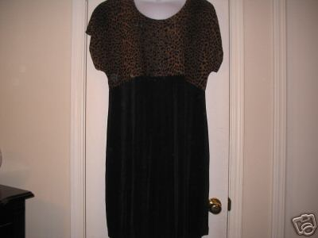
  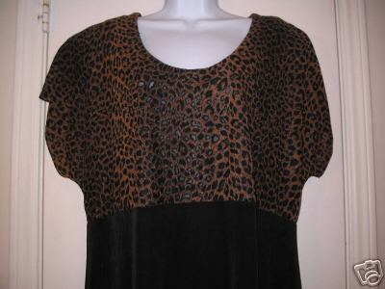
Bottom of Form



00035
The power of protection from AOL and eBay. Learn more

Shipping, payment details and return policy

Ships to
United States

Country:

Shipping and Handling | To | Service
US $4.25 | United States | US Postal Service Priority Mail®  Estimated delivery 2-3 days*

Top of Form

Country:

Shipping and Handling | To | Service
US $4.25 | United States | US Postal Service Priority Mail®  Estimated delivery 2-3 days*

Country:

Shipping and Handling | To | Service
US $4.25 | United States | US Postal Service Priority Mail®  Estimated delivery 2-3 days*

Bottom of Form

