$39.99 NWT Gorgeous Winter White Formal Pantsuit 22W | Item number: 160050830484

Bidder or seller of this item? Sign in for your status | Email to a friend | Printer Version

This item has been paid through PayPal. Payment was sent to: wdwgirls05@aol.com on Nov-18-06.
Top of Form
To let other eBay users know what your experience has been with this seller, click the Leave Feedback button.
Bottom of Form

Other actions for this item:

You can manage all your items in My eBay and do the following:
View payment details for this item.
View PayPal payment for this item.
Contact Seller about this item.
Additional Options:
To view other items from this seller, view seller's other items.
If this listing is similar to an item you want to sell, list an item like this.
You may add this seller to your Favorite Sellers in My eBay.

    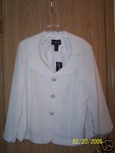
    View larger picture
    Winning bid: | US $39.99
    Ended: | Nov-18-06 10:49:30 PST
    Shipping costs: | US $9.00 (discount available)  US Postal Service Priority Mail®  Service to United States
    Ships to: | United States
    Item location: | Centralia, Washington, United States
    History: | 1 bid
    Winning bidder: | lovesmusic2( 395)
    You can also: | Email to a friend | Sell one like this
  Listing and payment details: Show
    Starting time: | Nov-11-06 10:49:30 PST
    Starting bid: | US $39.99
    Payment methods:
      PayPal (preferred),
      Other - See Payment Instructions for payment methods accepted
      See details
  Meet the seller
  Seller: | jntwalter( 186)
  Feedback: | 100% Positive
  Member: | since Feb-27-99 in United States
  Read feedback comments
  Ask seller a question
  Add to Favorite Sellers
  View seller's other items
  Contact the seller instantly
  Buy safely
  1. | Check the seller's reputation
  Score: 186 | 100% Positive
  Read feedback comments
  2. | Check how you're protected
   | Seller accepts returns.  7 Days Money Back
    Returns:This item is covered up to $1,000 See eligibility

Description

Item Specifics - Women's Suits, Jackets & Outfits
 | Style: | Dress Suits |  |  | Size Type: | Plus
 | Condition: | New: With Tags |  |  | Size: | 20W

NWT total $121 - This suit is cute enough to wear to a wedding or cocktail party. This is a two piece outfit that I have put together as a suit, but I want you to know the top and pants have different labels. The jacket label is Russell Kemp Woman sz 22W, retail $62.00, it is fully lined and has three pearl button closure, with beautiful collar and nice shaping and darts to create a shaped silhouette. The jacket fabric is polyester, rayon and spandex. The slacks are labeled Bob Mackie, retail tag is $49. The slacks are fully lined, polyester, rayon and a little spandex for some give when you sit. The fabric colors are identical and the textures are very close to identical, no one except you will know that these are two pieces from different makers. Please contact me if you want any additional information. Please check out my other auction items for coats, sweaters, dresses, swimsuits and more. Thanks!

Powered by eBay Turbo Lister

 |  | Select a picture
  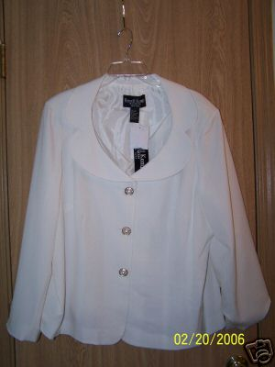
  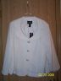 | 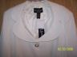
  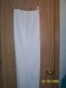
Bottom of Form

00014
The power of protection from AOL and eBay. Learn more
Questions from other members

 | Question & Answer | Answered On

 | Nov-17-06
   | Q: | What is the pant inseam measurement? What are the waist and hip measurements of the pants? What are the bust, waist, and hip measurement of the top?
 | A: | Pants inseam = 30 inches waist= 44 inches hips= 56 inches Jacket top - bust=52 inches waist=48 inches hip= 58 inches Hope this works for you!

