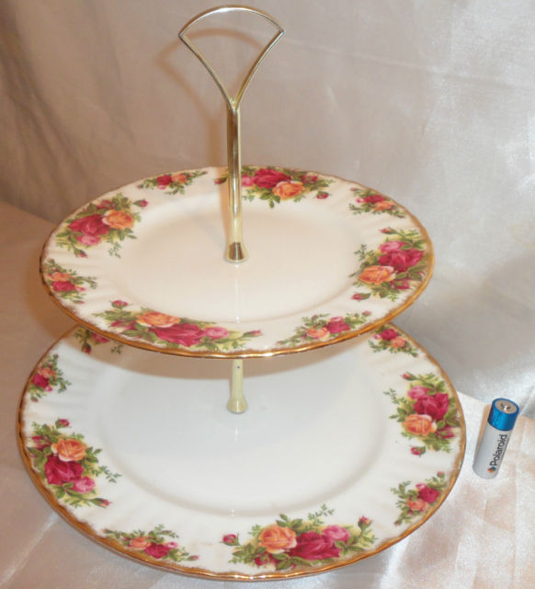

AN AUTHENTIC ROYAL ALBERT 1962 OLD COUNTRY ROSES 1ST QUALITY 2-TIER CAKE STAND!!
THIS CLASSIC & WORLDS MOST POPULAR PATTERN IS 1ST QUALITY.

A TRULY LOVELY CAKE STAND!

THIS WILL BE DISMANTLED & WRAPPED SECURELY FOR POSTING.

DIMENSIONS ARE 10" TALL 10.5" IN DIAMETER.

IN SUPERB CONDITION FREE FROM ANY DAMAGE.
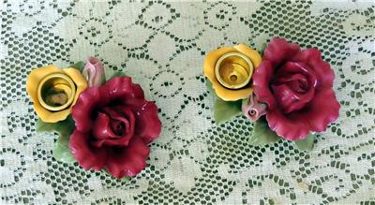

2 Floral Royal Albert Candle Holders-Old Country Roses Design..LOOK
A VINTAGE PAIR OF ROYAL ALBERT OLD COUNTRY ROSES FLORAL SHAPED CANDLE HOLDERS.....IN VERY NICE CONDITION...NO CHIPS OR CRACKS ON SET THAT I SEE OR 2 OTHER PEOPLE IN HOUSE RAN FINGERS AND CHECKED OUT PAIR TOO..... 2 INCHES TALL.....4 1/4 INCHES LONG....MARKED 1962 ROYAL ALBERT LTD ON BOTTOM ....AS SHOWN IN PICTURE.... A VERY UNIQUE SET OF CANDLE HOLDERS...A GREAT ADDITION TO ONES COLLECTION...BUYER TO PAY SHIPPING
SOLD for $29.99 and $7.80 shipping on EBAY 1-27-13
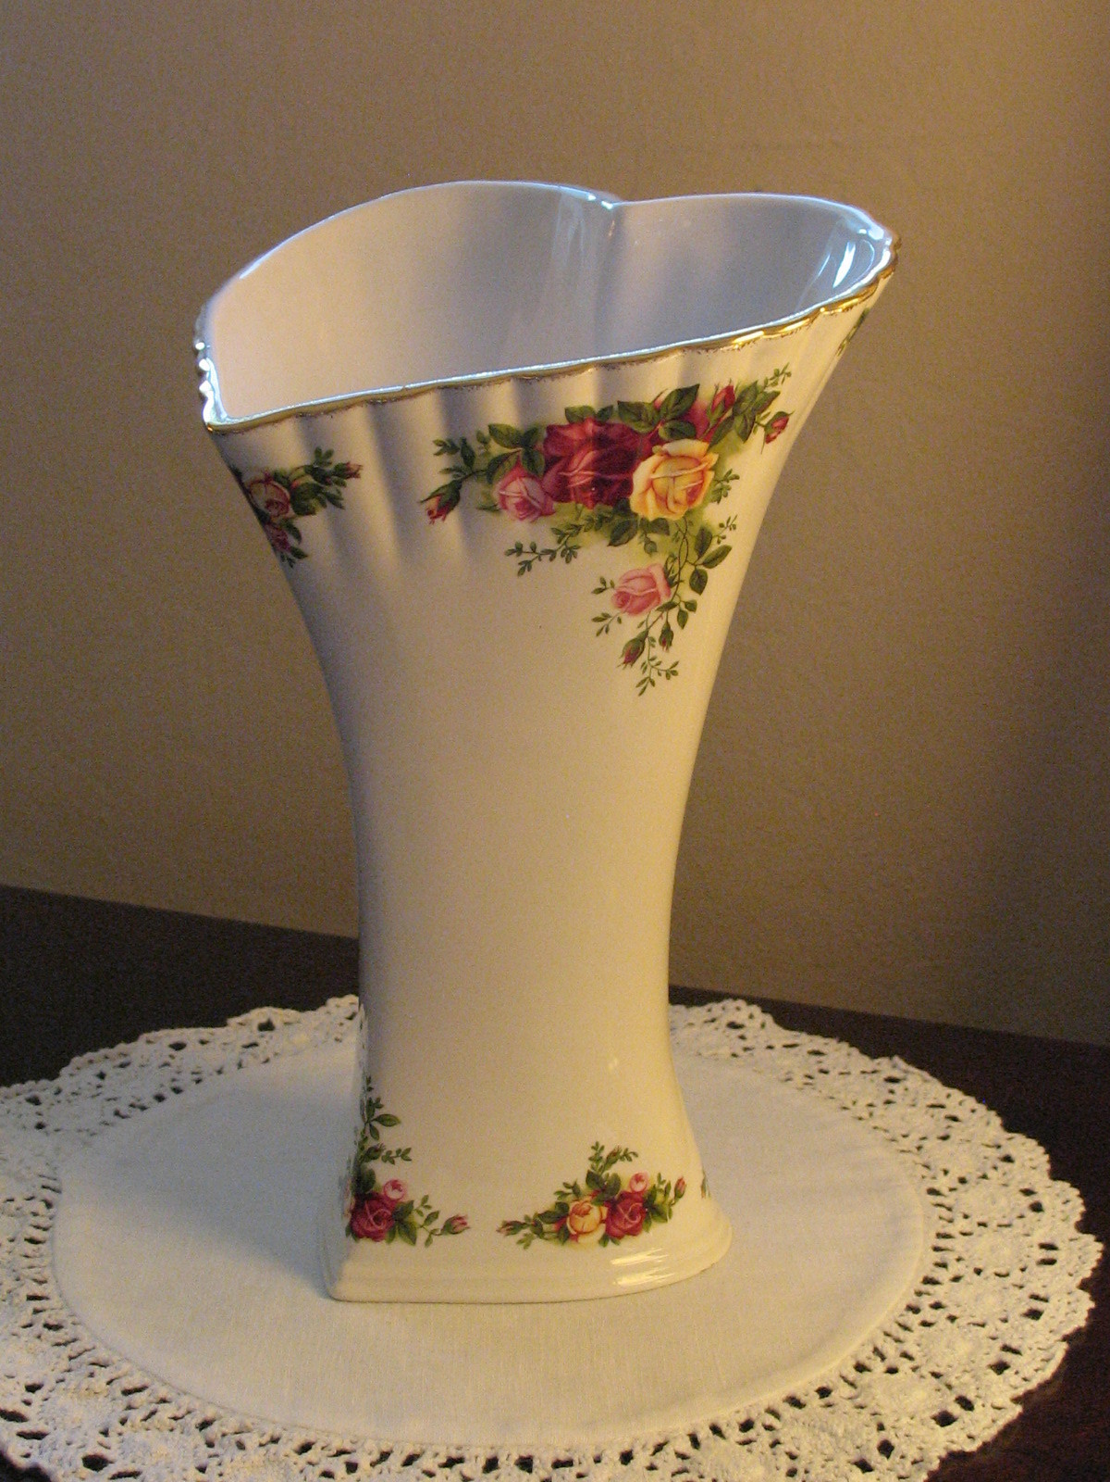

BEAUTIFUL ROYAL ALBERT OLD COUNTRY ROSES HEART SHAPED VASE – 9-1/2"
SOLD FOR $25.00 and $12.00 ECONOMY SHIPPING

BEAUTIFUL ROYAL ALBERT OLD COUNTRY ROSES HEART SHAPED VASE – 9-1/2”

This is a beautiful Royal Albert Old Country Roses vase. It is large at 9-1/2” high at the back and 8” at the front of the heart. The bottom is 4” and tapers out to 6-3/4” across the opening.

The vase is white and has the Old Country Rose design along the bottom and top and has gold trim at the rim. The bottom has the Royal Albert logo and is dated 1962.

This vase is in excellent condition with no chips or cracks or crazing.

This beautiful heart shaped vase filled with a bouquet of roses would make a wonderful Valentine’s Day gift for that special someone.

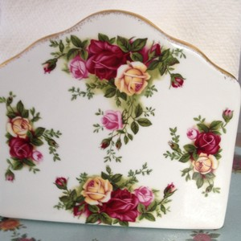

Old Country Roses Napkin Holder
SOLD FOR $61.00 plus $8.98 economy shipping 12-16-12

ANOTHER SOLD FOR $52.99 (4 bids) plus $9.95 standard shipping 12-12-12

ANOTHER sold for $49.95 plus $11.95 economy shipping 12-11-12
ANOTHER Sold for $75.00 plus FREE Economy Shipping 12-5-12
ANOTHER sold for $63.00 (23 bids) plus $8.00 economy shipping 12-2-12

You are bidding on an old country roses napkin holder. It is in perfect condition. It measures 5 inches at highest point and 2 1/4 inches wide. I only ship to US. Thanks

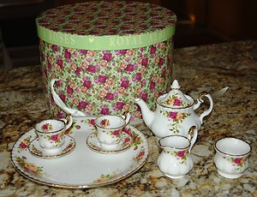
Mouse here to
Winning bid $41.00 plus $14.95 sold 11-10-12

Royal Albert Old Country Roses Child Tea Set
Teapot, Creamer, Sugar, 2 Cups/Saucers, Tray
Excellent Condition,No Chips Or Cracks
This Tea Set is part of a family estate and may have only been displayed which is the reason I am calling it used.
Comes in the original box and from a smoke and pet free home.

Royal Albert Old Country Roses Lite Up Flower Shop Gorgeous House In Excellent MIB

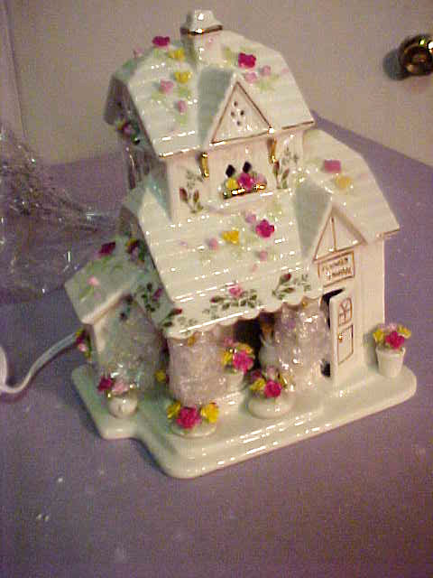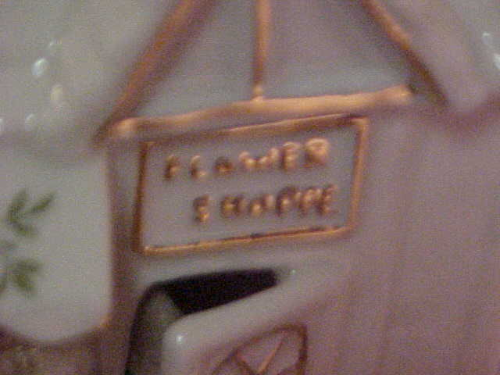
Sold for $50.00 plus $12.00 economy shipping 12-20-12
ANOTHER SOLD FOR $99.99 plus $10.60 economy shipping 11-15-12

The item for sale is a beautiful Royal Albert Old Country Roses Victorial Flower Shoppe Light up home. This measures 8 inches tall. The condition is mint, unused in the original packaging and box. Please see the pics. No reserve. Thank you.
Royal Albert china DEVILED EGG PLATTER plate "Old Country Roses" design
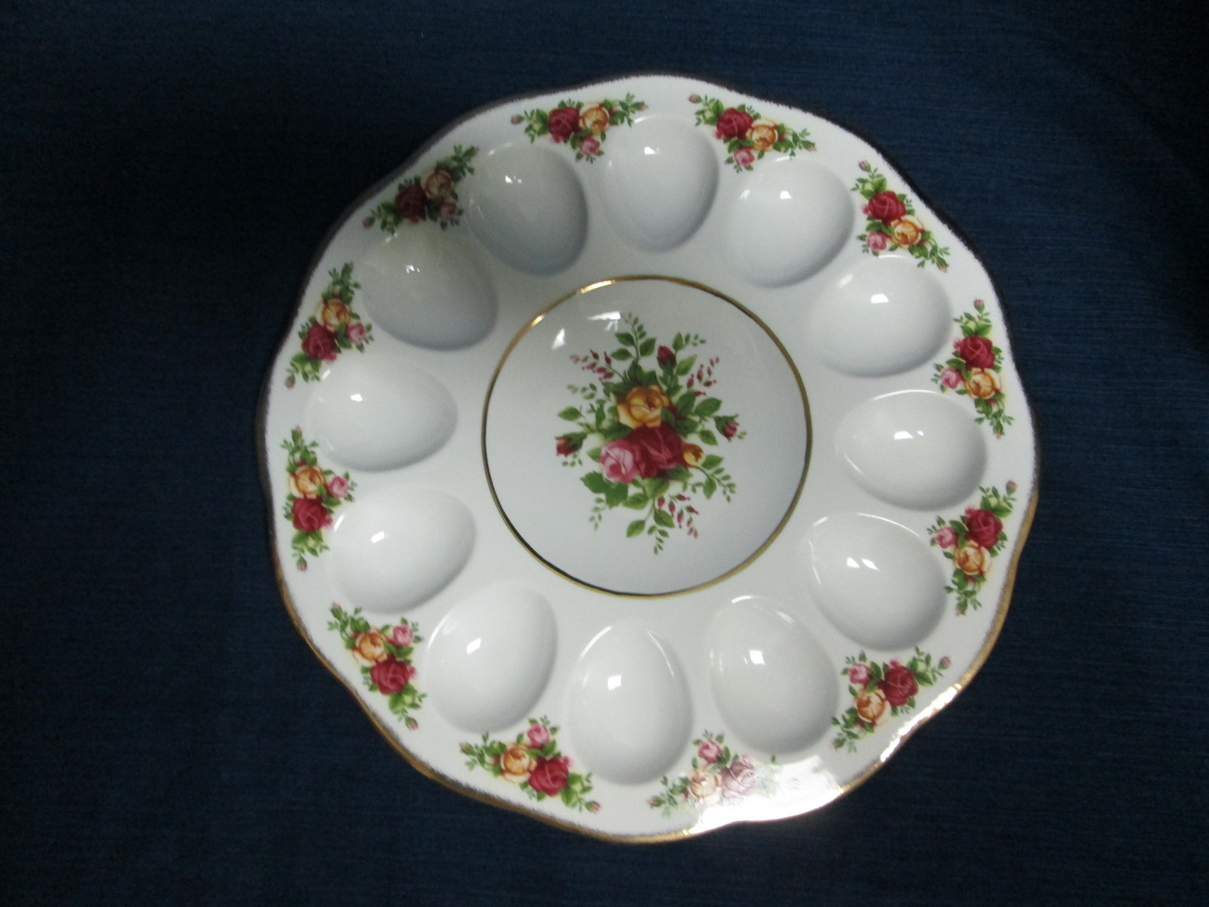

START AT $24.99 plus $11 shipping
This auction features a clean and well cared for Royal Albert china DEVILED EGG PLATTER plate "Old Country Roses" design. Measures 11" across. Very good condition; no chips or cracks or wear. Thank you for looking!!
This item is coming from a Smoke-Free Home.
Delivery Confirmation is included in the price.
PLEASE: Read all shipping details before bidding!
• Please Note: I will NOT ship out of the Continental United States of America. Please don’t ask for an exception.

BEAUTIFUL ROYAL ALBERT OLD COUNTRY ROSES HEART SHAPED VASE – 9-1/2"

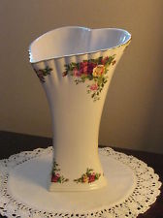
START BID AT $24.99 plus $11.00 shipping
BEAUTIFUL ROYAL ALBERT OLD COUNTRY ROSES HEART SHAPED VASE – 9-1/2”
This is a beautiful Royal Albert Old Country Roses vase. It is large at 9-1/2” high at the back and 8” at the front of the heart. The bottom is 4” and tapers out to 6-3/4” across the opening.
The vase is white and has the Old Country Rose design along the bottom and top and has gold trim at the rim. The bottom has the Royal Albert logo and is dated 1962.
This vase is in excellent condition with no chips or cracks or crazing.
This beautiful heart shaped vase filled with a bouquet of roses would make a wonderful Valentine’s Day gift for that special someone.
Thanks for looking.

